PL/SQL ASSIGNMENT -1

1. Display your name 5 times using for loop.

**Query:**

DECLARE

name VARCHAR2 (10):= 'Suvodeep';

BEGIN

FOR i IN 1..5

LOOP

DBMS_OUTPUT.put_line (name);

END LOOP;

END;

/

**Output:**

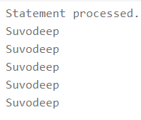

2. Write A PL/SQL block of code to invert a number 12345 to 54321

**Query:**

DECLARE

num number;

reverse_num number:=0;

begin

num:=98765;

while num>0

loop

reverse_num:=(reverse_num*10) + mod(num,10);

num:=trunc(num/10);

end loop;

dbms_output.put_line(' Reversed number is : '|| reverse_num);

end;

/

**Output:**

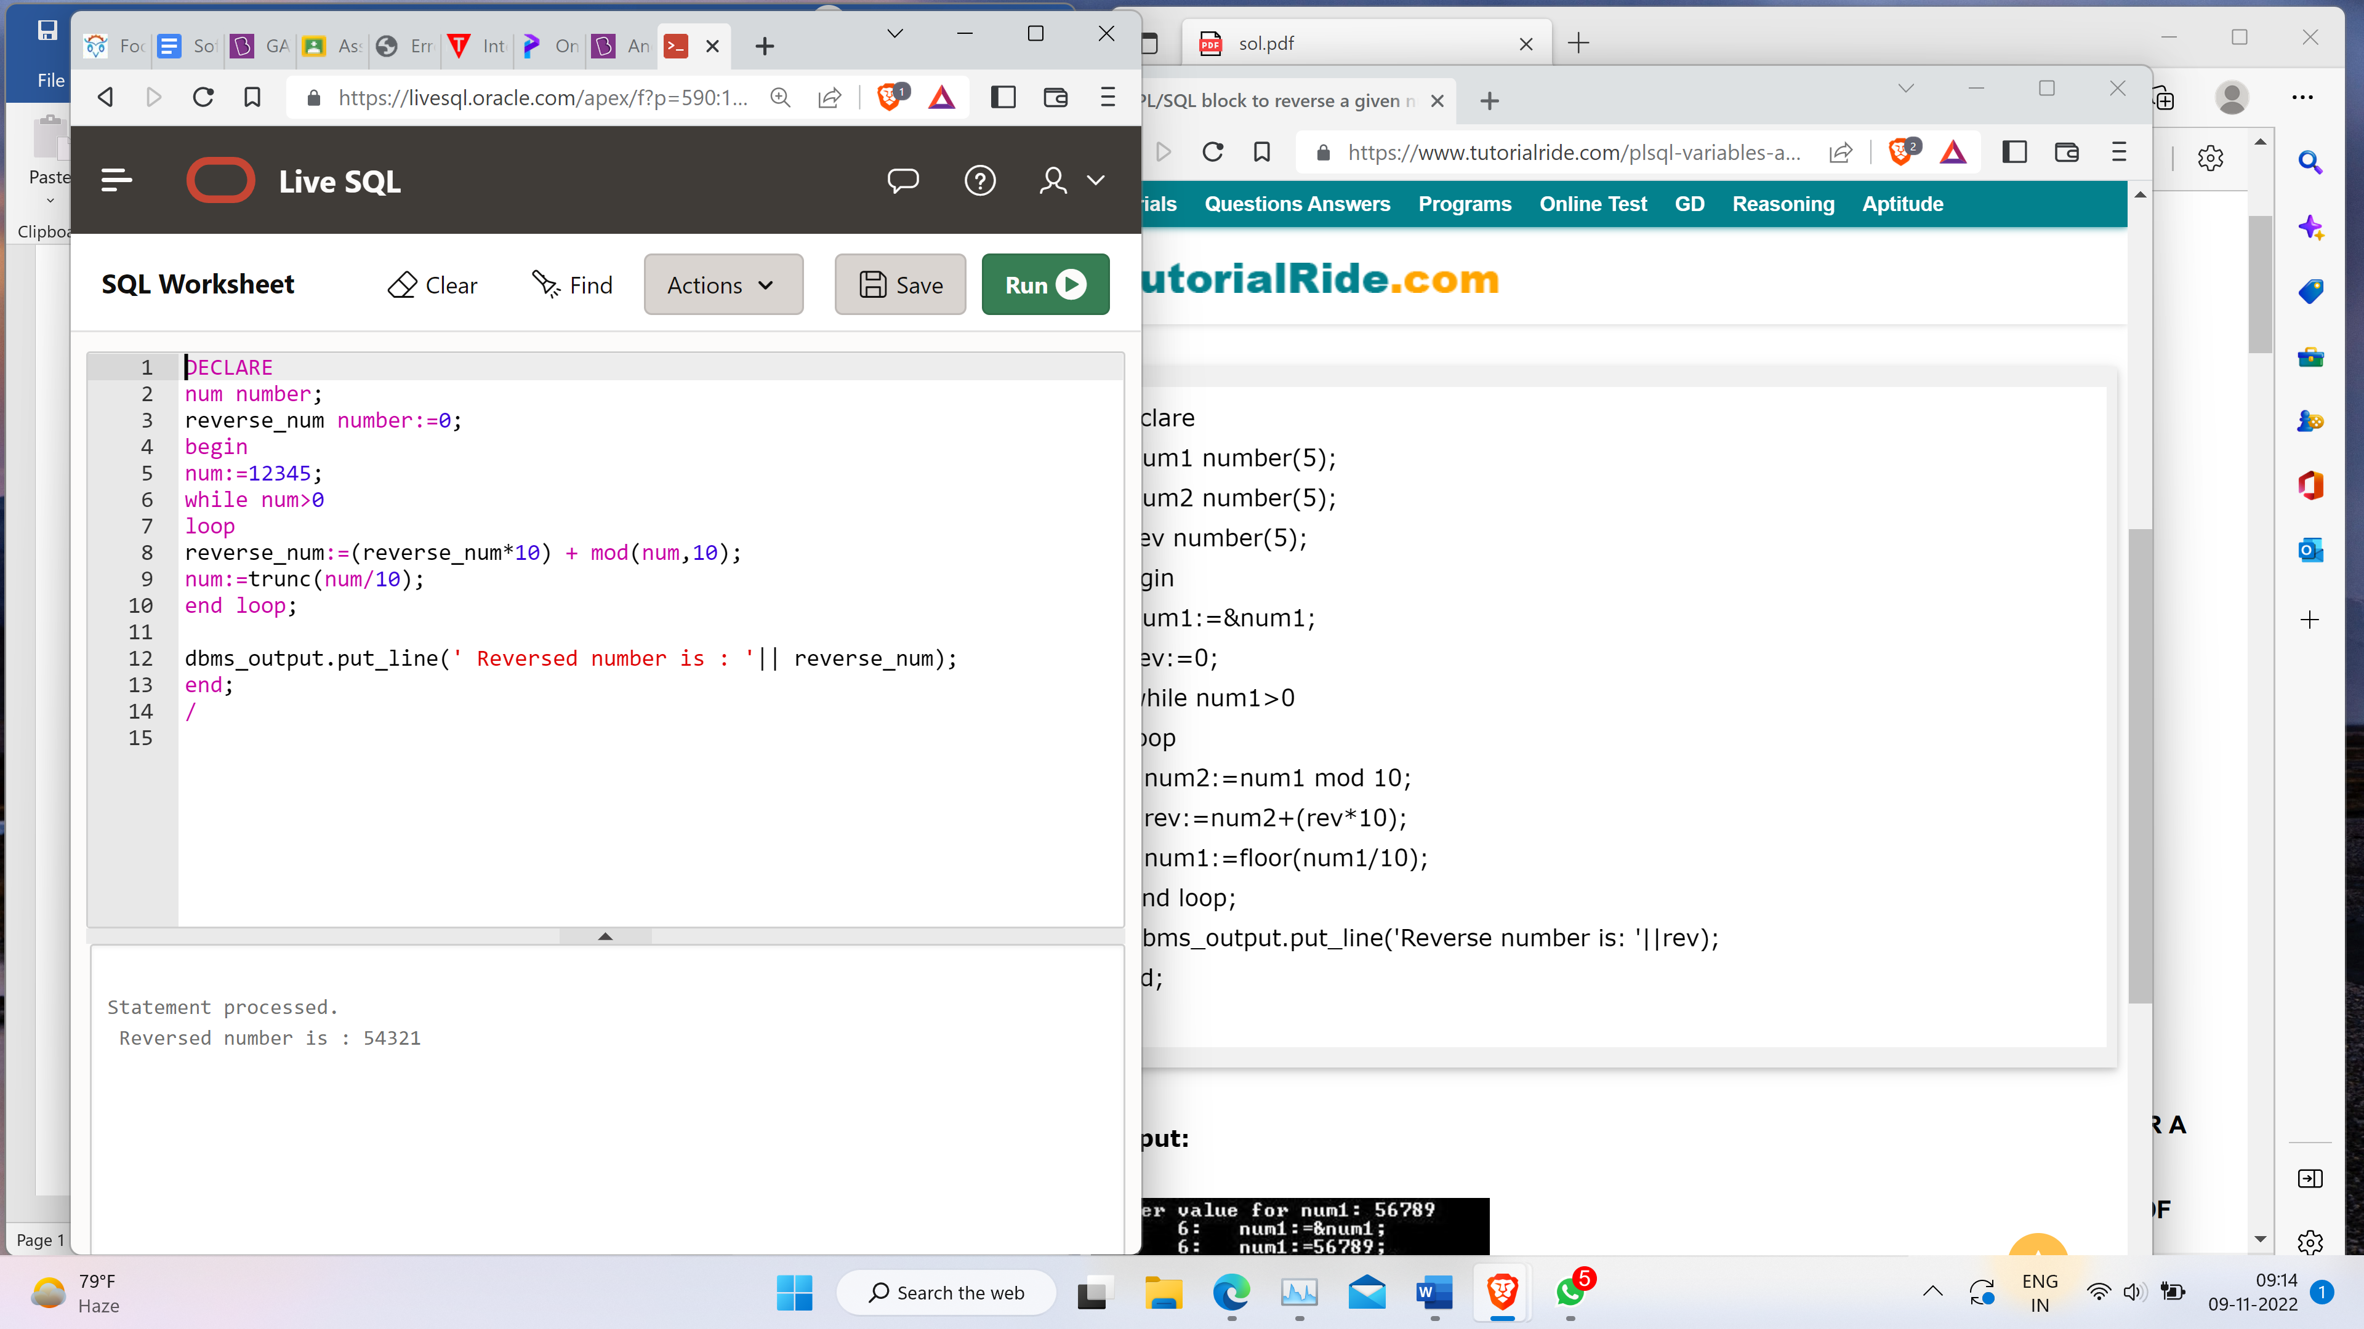

3. Write a pl/sql code block to calculate the area of circle for a value of radius varying from 3 to 7. store the radius & the corresponding values of calculated area in an empty table named areas, consisting of two columns, radius & area. Hint: create a table Area(radius,area), insert values into Area table through PL/SQL blocks.

**Query:**

create table areas ( r number(2), area number (14,2));

declare r number(5);

area number(14,2);

pi constant number (4,2):=3.14;

begin

r:=3;

while r<=7

loop

area:=pi*power(r,2);

insert into areas values(r,area );

r:=r+1;

end loop;

end;

/

select * from areas;

**Output:**

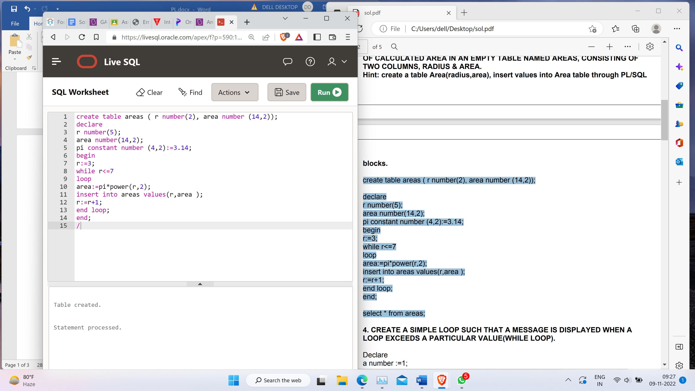

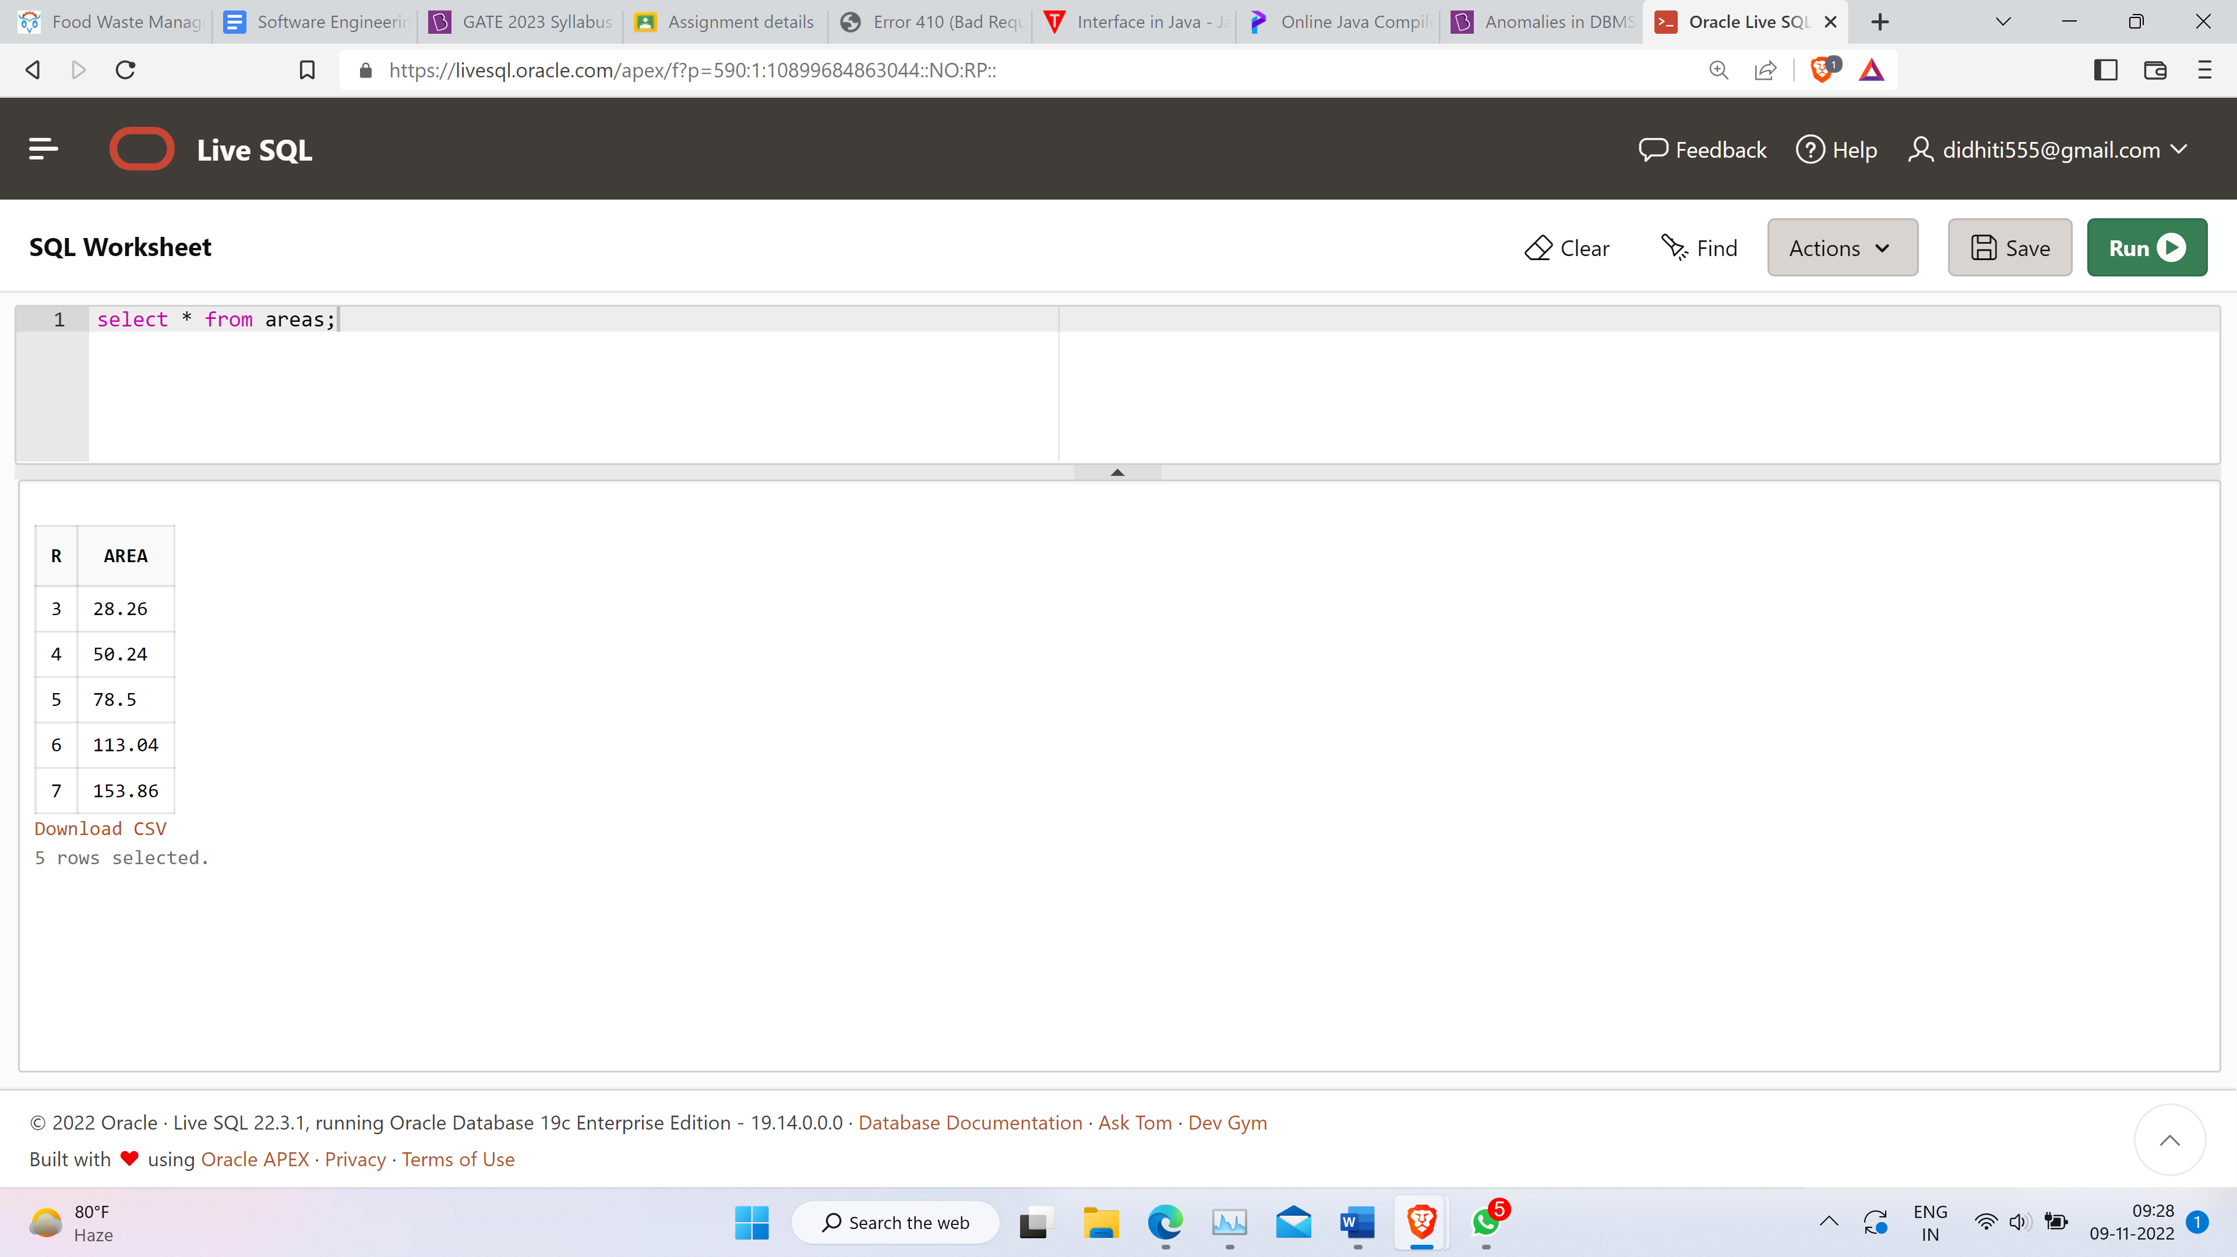

4. Create a simple loop such that a message is displayed when a loop exceeds a particular value(while loop).

**Query:**

Declare

a number :=1;

BEGIN

dbms_output.put_line('Program started');

LOOP

dbms_output.put_line(a);

a:=a+1;

Exit when a>5;

end loop;

dbms_output.put_line('Exceeded limit');

end;

/

**Output:**

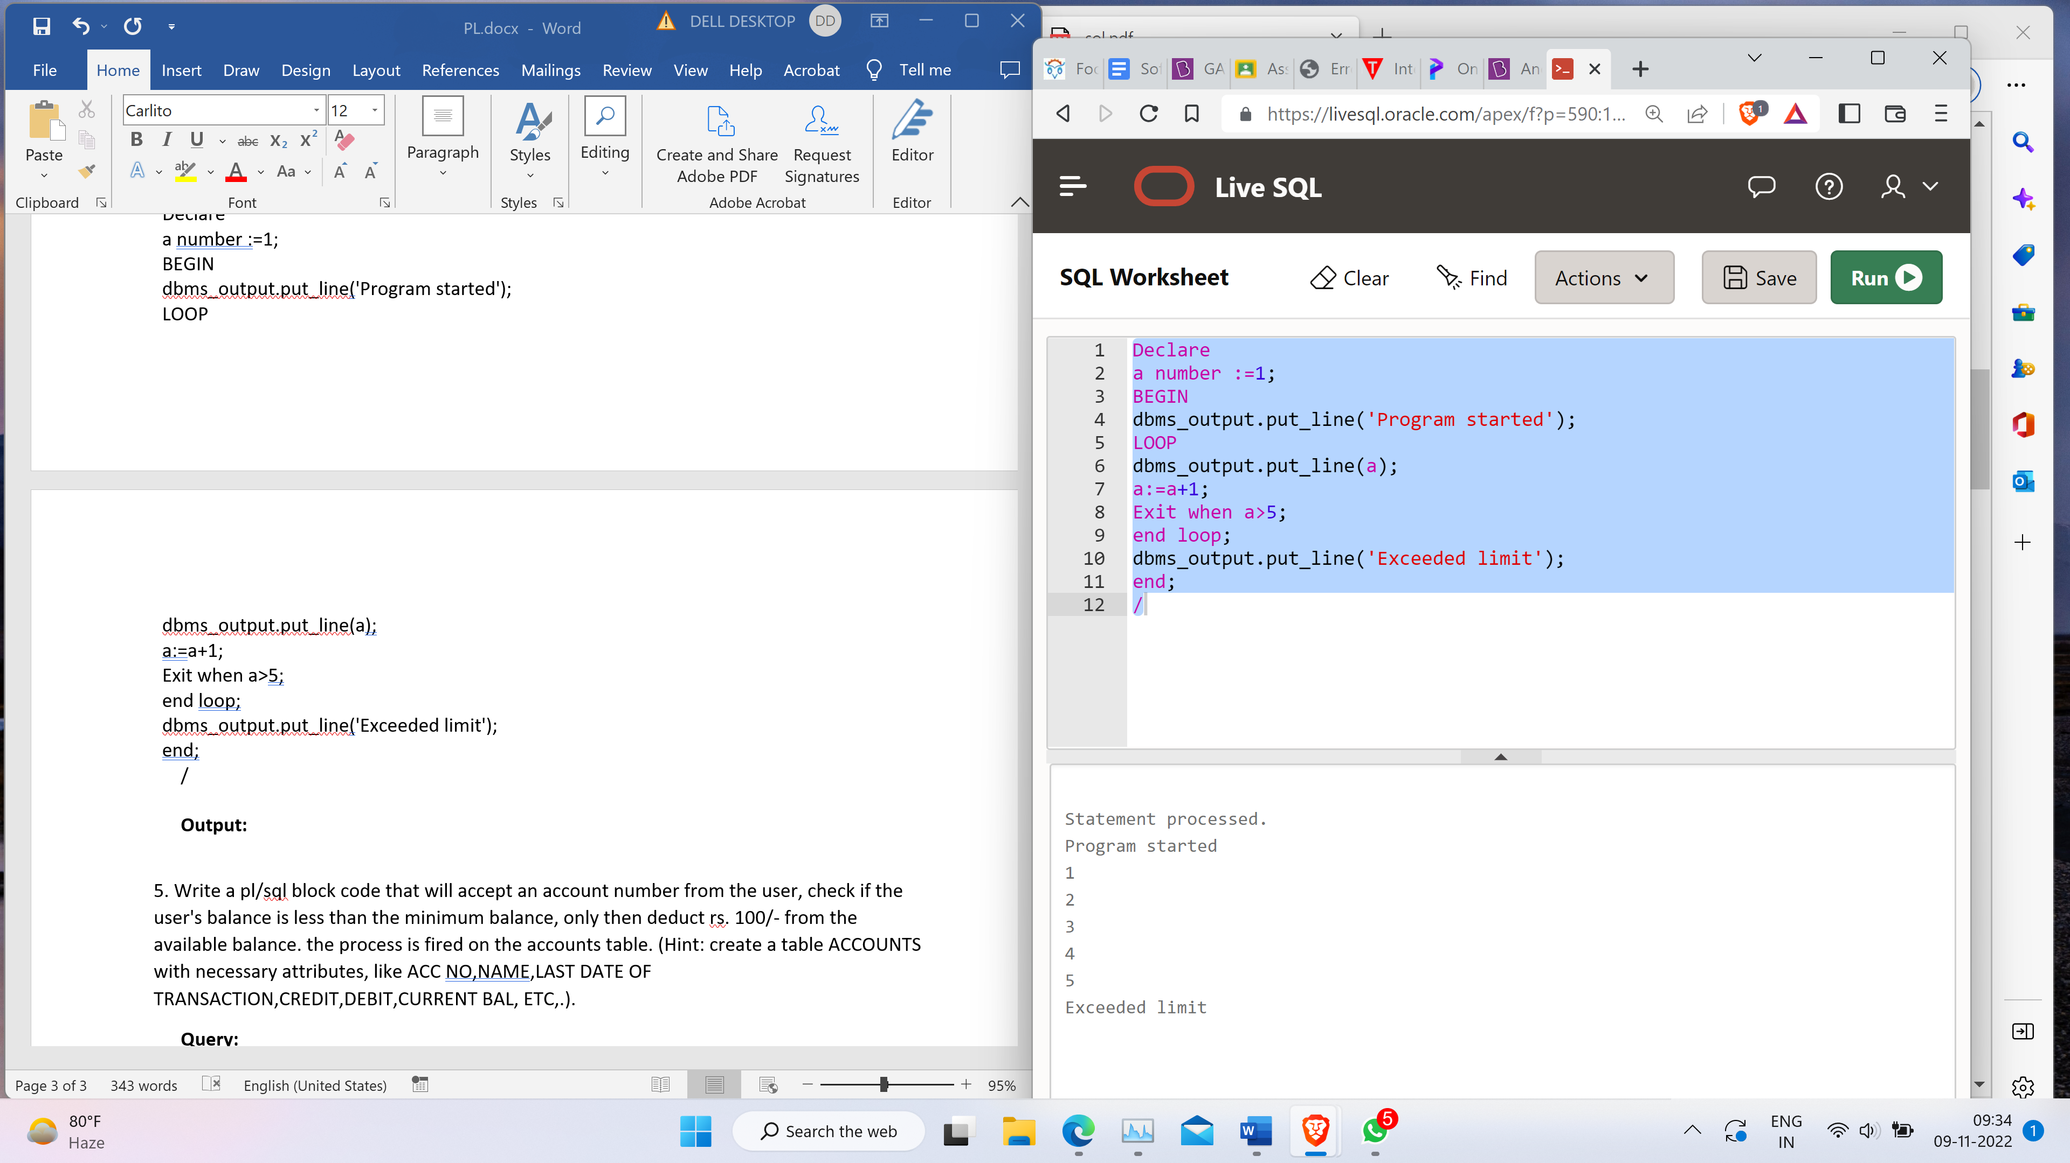

6. Write a function to find factorial of a number. Also call and check the factorial of a number.

**Query:**

factorial number;

create or replace FUNCTION fact(a number)

RETURN number

IS

f number;

BEGIN

IF a=0 THEN

f := 1;

ELSE

f := a * fact(a-1);

END IF;

RETURN f;

END ;

/

--calling function

set serveroutput on;

Declare

a number;

factorial number;

BEGIN

a:= 6;

factorial := fact(a);

dbms_output.put_line(' Factorial'|| a || 'is '|| factorial);

END;

/

**Output:**



7. Write a function to find maximum between two number

**Query:**

DECLARE

a number;

b number;

c number;

FUNCTION findMax(x IN number, y IN number)

RETURN number

IS

z number;

BEGIN

IF x > y THEN

z:= x;

ELSE

Z:= y;

END IF;

RETURN z;

END;

BEGIN

a:= 23;

b:= 45;

c := findMax(a, b);

dbms_output.put_line(' Maximum of (23,45):' || c);

END;

/

**Output:**

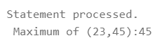

8. Write a Procedure using a IN and an OUT Parameter - to find maximum between two number.

**Query:**

DECLARE

a number;

b number;

c number;

PROCEDURE findMin(x IN number, y IN number, z OUT number) IS

BEGIN

IF x < y THEN

z:= x;

ELSE

z:= y;

END IF;

END;

BEGIN

a:= 23;

b:= 45;

findMin(a, b, c);

dbms_output.put_line(' Minimum of (23, 45) : ' || c);

END;

/

**Output:**

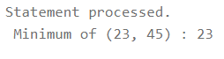

9. Write a Procedure using IN OUT Parameter – to find cube a number. Also call the

procedure to give output for a number.

**Query:**

set SERVEROUTPUT ON;

create or replace procedure INOUTPARA(p IN OUT number)

AS

BEGIN

p:=p*3;

END INOUTPARA;

**--**calling

declare

x number;

begin

x:= 15;

INOUTPARA(x);

dbms_output.put_line('The result is '||x);

end;

**Output:**

